

National University of Computer and Emerging Sciences



Emergency Expert

**FYP Team**

Abdul Rehman ………… 19L-1135

Anam Qaiser ………… 19L-1107

M. Saad Shafiq ………… 19L-2258

**Supervised by**

**Dr. Ali Afzal Malik**

**FAST School of Computing**

**National University of Computer and Emerging Sciences**

**Lahore, Pakistan**

**October 2022**

Anti-Plagiarism Declaration

This is to declare that the above publication produced under the:

**Title: ____Emergency Expert____**

is the sole contribution of the author(s) and no part hereof has been reproduced on **as it is** basis (cut and paste) which can be considered as **Plagiarism**. All referenced parts have been used to argue the idea and have been cited properly. I/We will be responsible and liable for any consequence if violation of this declaration is determined.

Date: ______________

Student 1

Name: __________________________

Signature: _______________________

Student 2

Name: __________________________

Signature: _______________________

Student 3

Name: __________________________

Signature: _______________________

Student 4

Name: __________________________

Signature: _______________________

_____________________________________________________________________

***Authors’ Declaration***

This states Authors’ declaration that the work presented in the report is their own, and has not been submitted/presented previously to any other institution or organization.

Abstract

Several people are distressed because of patients crowding a single medical institute and this overburdens the medical staff of the institute. Patient face issues such as unavailability of services/doctor/medicine or large travel time to reaching the hospital, which put the patient’s life in jeopardy by delaying their treatment. We plan to develop a mobile-based AI expert system application capable of diagnosing the patient’s illness, and then send them to the closest hospitals with all the treatment, equipment, medicine, a bed and doctor readily available so that the patient can receive the treatment instantly. The application will also help in the even distribution of patients and workload in all available medical institutes in a city. This will lead to the prevention of unnecessary loss of life.

**Executive Summary**

When a patient faces an emergency, in all the panic, they travel to a hospital that takes more time to reach than a nearby hospital because either the fear of incomplete services or not knowing about the existence/location of that hospital. This also minimizes the amount of time a doctor might have to save the patient’s life, as it is wasted in traveling to the farther hospital. Because of patients clustering at a single hospital, medical supplies often become scarce too, as, in such scenarios of catering to this many people, some medicine is bound to run out of stock.

All of these uncertainties, inconveniences and delays can decrease the chances of recovery/survival, and in some cases, even lead to loss of life.

The root causes are:

1. unequal scaling of the medical workload in the medical institutes of the city
2. patients visiting medical institutes that do not have the required treatment/doctors/medicine
3. large travel time required to reach the hospital

After careful analysis of the root causes, we propose to build a mobile-based AI expert system application that first asks users to enter their symptoms (or with an illiterate user, ask them simple yes/no questions), and diagnose their illness with a certain threshold of certainty and guide them to a medical institute with all the requirements.

In this report, we will have a detailed view of all the health care problems that our FYP is resolving, all the field related to the problems or being affected by the problems that we have identified. We will then have a comparison of our project with the products that are available in the market and see how our project differ. We will analyze the research papers and articles that have been published related to our work. We will then discuss the functionalities and requirements that are project must fulfil in order to be considered deployable and what services our project must provide

Table of Contents

Table of Contents i

List of Tables iii

List of Figures iv

Chapter 1: Introduction 5

1.1 Purpose of this Project 5

1.1.1 Guidance of the Patients in Emergency 5

1.1.2 Optimal Utilization of All Medical Institutes 5

1.2 Intended Audience 6

1.2.1 Patients 6

1.2.2 Hospital Staff 6

1.2.3 Pharmacy 6

1.2.4 Pharmaceutical Companies 6

Chapter 2: Project Vision 7

2.1 Problem Domain Overview 7

2.2 Problem Statement 7

2.3 Problem Elaboration 7

2.4 Goals and Objectives 8

2.5 Project Scope 8

2.6 Sustainable Development Goal (SDG) 9

2.7 Constraints 9

2.8 Business Opportunity 9

2.9 Stakeholders Description/ User Characteristics 9

2.9.1 Stakeholders Summary 9

2.9.2 Key High-Level Goals and Problems of Stakeholders 10

Chapter 3: Related Work 12

3.1 Comparison with Existing Services 12

3.2 Hospital Bed Management Methodologies 12

3.3 Pharmacy Inventory Management Methodologies 13

3.3.1 Visual Method 13

3.3.2 Periodic Method 13

3.3.3 Perpetual Method 13

3.4 Optimal Route Algorithm 13

Chapter 4: Software Requirement Specifications 15

4.1 List of Features 15

4.2 Functional Requirements 15

4.3 Non-Functional Requirements 15

4.3.1 Performance 15

4.3.2 Scalability 15

4.3.3 Capacity 15

4.3.4 Availability 15

4.3.5 Reliability 15

4.3.6 Recoverability 16

4.3.7 Maintainability 16

4.3.8 Security 16

4.4 Assumptions 16

4.5 Software Requirements 16

4.5.1 Programming Language 16

4.5.2 Google API’s 16

4.5.3 Database 17

4.6 Use Cases 17

4.6.1 Login 17

4.6.2 Sign Up 17

4.6.3 Go to Near-By Hospital Location 18

4.6.4 Diagnose Illness 18

4.6.5 Order Medicine 19

4.6.6 Book Bed 19

4.6.7 Make Appointment 20

4.7 Graphical User Interface 21

4.8 Database Design 25

4.8.1 ER Diagram 25

4.8.2 Data Dictionary 25

4.9 Risk Analysis 26

4.9.1 Financial 26

4.9.2 Legal 26

4.9.3 Ethical 26

References 26

List of Tables

Table 1: Comparison with Market Products 12

Table 2: Data Dictionary 25

List of Figures

Figure 1.1: Front Page 21

Figure 1.2: Hospital List Page 21

Figure 1.3: Map Page 21

Figure 1.4: Diagnose Page 22

Figure 1.5: Result Page 22

Figure 1.6: Sign Up Page 23

Figure 1.7: Log In Page 23

Figure 1.8: Home Page 24

Figure 1.9: User Page 24

Figure 1.10: Database ER Diagram 25

# Introduction

In moments of mass crisis (such as COVID-19, earthquakes etc.), patients usually go to a single well-known large government hospital, which causes an overload of patients at a single hospital. The hospital staff give their best efforts to cater all the patients, but even to the best of their abilities, a considerable number of patients cannot receive beds or doctors or treatment timely.

When a patient faces an emergency, in all the panic, they travel to a hospital that takes more time to reach than a nearby hospital because either the fear of incomplete services or not knowing about the existence/location of that hospital. This also minimizes the amount of time a doctor might have to save the patient’s life, as it is wasted in traveling to the farther hospital.

Even if the patient is aware of the location of the nearby private hospitals/semi-private hospitals/clinics (all available to cater for the patient’s needs), because of the doubts such as:

1. Unavailability of desired medical treatments
2. Unavailability of qualified doctors
3. Fear of huge check-up fees
4. Unavailability of good medical equipment

Patients avoid taking the chance.

Because of patients clustering at a single hospital, medical supplies often become scarce too, as, in such scenarios of catering to this many people, some medicine is bound to run out of stock, and restocking can take a consider amount of time which can prove to be curtail for the the treatment of the patient. So, the short of medical supplies will eventually put the safety of the patient’s life at risk.

## Purpose of this Project

The Purpose of this project is to develop a mobile-based AI expert system application, which can aid in the following:

### Guidance of the Patients in Emergency

The application will be capable of diagnosing the patient’s illness using simple questions with only yes or no answers so that can be easily understood by the users, and then send them to the closest hospitals with all the treatment, equipment, medicine, a bed and doctor readily available so that the patient can receive the treatment instantly.

### Optimal Utilization of All Medical Institutes

The application will also help in the even distribution of patients and workload in all available medical institutes in a city. This will lead to the full and optimal utilization of all the medical power of a city in moments of mass crisis. This will lead to the prevention of unnecessary loss of life due to the improper management of the medical resources by the head authorities in case of an alarming situation .

## Intended Audience

The audience and professionals that can be affected by this project and utilize its use to either find comfort and ease in receiving treatment or better manage the services that they provide are as listed below:

### Patients

Patients will receive great assistance in finding the medical institutes that best cater their needs and will be free from the worries of the unavailability of treatment, medicine or equipment while go for a check-up at the hospital. The patient will also be able to see whether the budget of treatment at the medical institute is friendly with their pockets or not and then can a more suitable choice.

### Hospital Staff

Hospital Staff will be able to manage the patients in a more effective and arranged manner and also being at ease from the worries of loss of life due to improper management of resources in timely manner. They will also be able to redirect the patient’s more swiftly and timely and prevent them any sort of inconvenience.

### Pharmacy

Pharmacy will be able to manage orders of medicine requested by the Patients in case they are unable to find the medicine at the hospital pharmacy due to shortage of medical supplies. Pharmacies will also be able to maintain record of their sales and stock of medical supplies. This will also lower their efforts for management of their orders with pharmaceutical companies to restock on medicine and avoid the risk of shortage of medicine.

### Pharmaceutical Companies

Companies will be able to more efficiently send supplies to the pharmacies and will be able to fulfill the demand of their products and medicines, timely and effectively.

So, in this project, we will further understand the vision of our project and the problems that the project is offering solution for. We will see some work and products that are already in market and identity the difference in services that our project is offering that are missing in the already existing market products and services. We will also look all the requirements that must be fulfilled for the development and deployment of this project in the market.

# Project Vision

The Vision of this project is to improve the health care system. Health Care is an important part of the human life but while dealing with the larger concerns, we sometimes tend to ignore the little problems, which if left unattended for a long period of time, can become the cause of major incidents. The problems that are project is trying to counter may seem small but they have proven to become the cause of death of a considerable number of Patients in Pakistan. In the field of Health Care, even a single loss of live is unacceptable and can cause serious difficulties for the hospital or the personal related to that case.

## Problem Domain Overview

The Problems we identified are mainly concerned with efficient traveling time, informed decisioning of patient for choosing a treatment center and proper resource management of the medical institute. Our project will assist in helping the patient make an informed decision by giving them easy access to information which is critical for that decision as well as useful recommendations based on expert knowledge, provide them optimal paths to reach their destination so that the traveling time can be as low as possible and provide means for the medical institutes such as hospitals, pharmacies and pharmaceutical companies to provide their services more effectively.

## Problem Statement

Loss of a Patient’s life due to either unavailability of beds and medical services in the hospital where the patient has chosen to go in an emergency situation or the deterioration of patient’s health and lowering chances of survival due to long travelling time for reaching a medical institute of Patient’s choice, is a crucial concern for the country.

## Problem Elaboration

When in a state of panic, it is natural for a human to make decision there and then, instead of waiting to gather information and then make an informed decision. In case of Health Care, in emergency case, the patient does not have the time to verify and check the location of the closest hospital and whether or not if the desired services are there. The patient impulsively and instinctively rushes to a familiar or trustworthy institute to save their health. In this hastiness, they go to the institutes that are well-known, but sometimes they are far and due to the deny in instant treatment, the health is compromised.

Even if we arrive to the medical institute on time, time taken to verify the availability of the bed and medical services forces the patient to wait and, in that wait, the health is being put at risk and if it is found that the bed is unavailable then relocating to another medical institute again raises the issue of delay in treatment due to traveling.

Even if the above two case do not hinder the health of patient, the lack of medical supplies, or overburdening of the doctor on duty, will definitely affect in the performance of the medical institute again endangering the patient.

There might not seem as major issues individually, but it put together, they pose a serious threat to the patient’s life. We have seemed many cases in Pakistan where people have faced difficulties cause of the above identified concerns.

## Goals and Objectives

Objectives of this project are listed below:

* Creating an Expert System for effectively diagnose the disease

(via simple Questions)

* Find the nearest hospitals that provides the treatment for the diagnosed disease
* Check the availability of beds in the hospitals
* Check the availability of Doctors in the hospitals
* Check the availability of tests and equipment related to the diagnosed disease in hospital Labs or Labs in a nearby fixed vicinity of the hospitals
* Check the availability of medicines related to the diagnosed disease in the hospital Pharmacy or Pharmacies in a nearby fixed vicinity of the hospital
* Check the rush in the wards and estimate waiting time for availability of bed/treatment to assist the patient in deciding if he should wait or move to a different institute
* Rank the hospitals according to their services and patient feedback
* Assist the patient in getting a token/reservation/appointment in a hospital

(only in cases of the hospitals which work on token system)

* Provide the optimal route to the hospital selected by the patient
* Assist the Hospital Staff in management of the beds
* Assist the Hospital Staff in redirecting the patients to any nearby hospital with the desired services (if necessary)

## Project Scope

This project is an industrial level project which requires a large amount of computational power and resources along with real-time data of the medical institutes, to reach its full potential. With the vast variations of unlimited number of diseases/illnesses (all related to a distinctive field of medical science i.e. Optometry, Dentistry, Radiology, Neurology, Cardiology etc.), there is also the challenge of developing an expert system capable of identifying these vast variety of diseases, which, with the limited time of 1 year, is highly difficult to achieve.

With the limited time, we aim to make a prototype of our model in our tenure of FYP and be sure to achieve as many functionalities as possible.

Therefore, the scope of the project will cover the following functionalities:

* Diagnosis of common illness and diseases

(via simple Questions)

* Find the nearest hospitals that provides the treatment for the diagnosed illness
* Check the availability of beds in the hospitals
* Check the availability of Doctors in the hospitals

(via simple Availability Status)

* Check the availability of medicine needed for the diagnosed illness
* Estimate minimum waiting time for availability of beds in the hospital
* Assist the Hospital Staff in management of the beds
* Provide the optimal route to the hospital selected by the patient
* Ranking of hospitals on patient feedback
* Assist the Hospital Staff in redirecting the patients to any nearby hospital with the desired services (if necessary)

More Advance Functionalities such as: Advancement of the Diagnosis system for identification of more diseases, Verification of the documentation and registrations of hospitals, Check the availability of tests and equipment related to the diagnosed disease in hospital Labs or Labs in a nearby fixed vicinity of the hospitals, Verification of the documentation and registrations of pharmacies etc. will be employed in the further future extension of the project after the tenure of the FYP

## Sustainable Development Goal (SDG)

Good Health and Well Being is our main concern in Pakistan. We want to be able to improve the provision of Health Care services in Pakistan as the well-being of our public will eventually ensure a brighter future for our country and upcoming generation.

## Constraints

The constraints that can be faced are:

1. Efficiency of the system that we are recommending
2. Trust of the general public on our services
3. Correctness of information provided by the medical institutes
4. Completeness of the data provided by the pharmacies
5. Real time assessment of the optimal route

## Business Opportunity

This project has a fairly well business opportunity in the Health Care field. There is nothing more important to a person than their own health or the health of their loved ones. One can charge a reasonable amount as fee to the hospitals, clinics and the pharmacies that will be registered on the platform of this project as the use of our services will eventually lead to the boost in their sales and overall performance. And with the help on in-built medicine promotion services, we can target pharmaceutical companies for a fee to advertise their medicine.

## Stakeholders Description/ User Characteristics

Health care is a vast field and concerns many other fields parallel to it in the well-being of Human Beings. Major of them will belong to the medical institutes and medicine provider and production companies. A few of the stakeholders we have identified are as follows:

### Stakeholders Summary

#### Hospitals

They can use these services to manage their patients in real time and quickly redirect them to their other branches, to not only avoid incidents caused by mis-management but also to effectively cater more patients.

#### Pharmacy

They will be able to boost their sales by effectively handling the demand of medicine of the Patients and they will be able to counter the issue of restocking on medicine that are facing shortage more effectively.

#### **Pharmaceutical** **company**

They will be able to better cater the production demands of their medicines and products as they will be able to analyze the real time demand of the medicine in the pharmacies and start production of that product in the desired amount.

### Key High-Level Goals and Problems of Stakeholders

#### Hospitals

***Goal***

We plan to have all the medical institutes available in each city to be registered on our platform.

***Problem***

This will require that the hospitals will agree to the terms of providing us real time data of the operations and cases that are being dealt at their institute. This will also require us to have access to the information related to the doctors that are appointed at the hospitals. Also, the registration fee paid be the hospital to be able to be registered on our platform will have to be justified by their improvement in conduction of their tasks to provide effective and timely treatment to the patients. We will require a certification of their medical status to authenticate that their status is officially recognized as a medical institute by credible and well-renowned institutes with the confidence of the public

#### Pharmacy

***Goal***

We plan to have all the well-renowned pharmacies to registered on our platform.

***Problem***

This requires that they provide us real-time data of their inventory and their sales and purchase. Pharmacy registration charges must be balanced out by their gain in sales. We will require a certification of their pharmacy status to authenticate that their status is officially recognized as a pharmacy by credible and well-renowned institutes with the confidence of the public

#### **Pharmaceutical** company

***Goal***

We plan to have all the top pharmaceutical firms to registered on our platform

***Problem***

We will require real-time data of their production and sales. We will require a certification of their medical status to authenticate that their status is officially recognized as a medical institute by credible and well-renowned institutes with the confidence of the public.

# Related Work

In this chapter, we will review research papers and articles that fall under the same field of work as our Project. We will also analyze information (from multiple highly credible sources) that have deepened our understanding of different components of our Project and guide us in their implementation.

## Comparison with Existing Services

In order to understand what is already available in the market and to distinguish how our product is different from those services that are already existing in the market, we have made a simple comparison table to illustrate the difference in the products.

Table 1: Comparison with Market Products

|  |  |  |  |  |  |  |  |  |  |
| --- | --- | --- | --- | --- | --- | --- | --- | --- | --- |
| Services  Features |  | Diagnose Illness | Bed Availability | Doctor  Availability | Medicine Availability | Medical Equipment Availability | Required Test Availability at Hospital Lab | Optimal Route to Hospital |  |
| Mayo Clinic [1] |  |  |  |  |  |  |  |  |  |
| WebMD [1] |  |  |  |  |  |  |  |  |  |
| Your.MD [1] |  |  |  |  |  |  |  |  |  |
| IMS Maxims [2] |  |  |  |  |  |  |  |  |  |
| Symptomate [1] |  |  |  |  |  |  |  |  |  |
| Ada-  The personal Doctor [1] |  |  |  |  |  |  |  |  |  |
| Acgil [2] |  |  |  |  |  |  |  |  |  |
| Emergency Expert |  |  |  |  |  |  |  |  |  |

Note: The Information is drawn from Ref. [1] and Ref. [2].

Through the above table, it can be clearly seen that currently there are no product that provides all the functionalities given by our project.

## Hospital Bed Management Methodologies

For the Bed Management System Development, using the TOC to create an interface for the targeted hospitals help form the basis for improving bed management processes and increasing the understanding among the hospital staff with regard to operational functions and the existing constraints that cause problems in the bed management of the Hospitals. ( Source: Ref. [4] ). This will require the effective training of the hospital staff for the effective and proper use of the project.

## Pharmacy Inventory Management Methodologies

As for the Effective Management of the pharmacy Inventory, there are three methods used in pharmacy to manage inventory ( Source: Ref. [5] ), are given below:

### Visual Method

This Method is to train the Pharmacist in such a manner so that he can verify the need to restock by only the use of vision. Furthermore, labels and tags are used to navigate through the supplies of the pharmacy. The issue with this is human can be trained but to a limit and there is always room for error, therefore, this method has failed to provide surety and consistency.

### Periodic Method

This Method is to verify the need to restock by checking the stock of each medicine after a fixed period of time. (i.e. weekly, monthly). The issue is if the medicine is out of stock before the verification date, this cause failure to provide surety and consistency.

### Perpetual Method

This Method is to verify the need to restock on medicine by sending the check inspectors of the pharmaceutical companies to the pharmacies to get the demand of supplies (if any). This also has room for error as sometimes that inspectors can overlook a pharmacy that they were supposed to visit, which can be troublesome.

In our system, we will be creating an interface that can best cater and deal with all the issues faced by the above-mentioned methods for optimal performance.

## Optimal Route Algorithm

In today’s era, Google Maps API is the most widely used API for route planning as it searches the best route using the Genetic Algorithms in real time. The main advantage of Genetic Algorithm is that it produces a number of different optimal solutions since the result can differ every time the Genetic Algorithm is executed to be best suited to the real time environment. ( Source: Ref. [6] ). The disadvantage is that Google API follows some regulations that are recognized by the international community but are not applied in every country. For the route to be optimal in Pakistan, taking in account the various environmental conditions, we will be applying additional constraints and Algorithms in order to obtain a more optimal route.

So, we can conclude that all the related work that we have looked support our agendas but as to a similar product in the market, currently there is no similar product that provide the same services as our project.

# Software Requirement Specifications

## List of Features

They are as follows:

* Diagnosis of common illness and diseases (via simple Questions)
* Find the nearest hospitals that provides the treatment for the diagnosed illness
* Check the availability of beds in the hospitals
* Check the availability of Doctors in the hospitals (via simple Availability Status)
* Check the availability of medicine needed for the diagnosed illness
* Estimate minimum waiting time for availability of beds in the hospital
* Assist the Hospital Staff in management of the beds
* Provide the optimal route to the hospital selected by the patient
* Ranking of hospitals on patient feedback
* Assist the Hospital Staff in redirecting the patients to any nearby hospital with the desired services (if necessary)

## Functional Requirements

* System shall let users create a new account.
* System shall authorize the unique phone number, password from the user and allow users to login.
* System shall allow users to find nearest hospital location on the map
* System shall allow users to order medicine from the nearby pharmacies.
* System shall allow users to book a bed in a ward of a hospital.
* System shall allow users to make an appointment with a doctor.
* System shall allow users to diagnose his illness via simple question answers.

## Non-Functional Requirements

### Performance

The application should have good performance in terms of response time.

### Scalability

The application should be easily scalable with the addition of new servers on the network.

### Capacity

The application should be able to handle large number of traffic and users.

### Availability

The application should be up and running all the time.

### Reliability

The application should give accurate results in the diagnose of illness and optimal route plan.

### Recoverability

The application should easily recover from any incident that hinder its services.

### Maintainability

The application should have low maintenance cost.

### Security

The application should have good security for the safeguard of the information of the hospitals, pharmacies and the patients.

## Assumptions

The Assumptions that we are make are as follows:

1. The user will be literate enough to understand and answer the questions for diagnose
2. The Hospitals will provide correct information
3. The Pharmacies will provide correct information
4. The user will know how to navigate through the application cause of user-friendly GUI.

## Software Requirements

### Programming Language

#### Python

This system shall make use of the programming language, python, for its functionality on the server side. Within this language, we shall also use various libraries with python such as NumPy and selenium etc. as well for testing.

#### Java

The major application that we are developing for use by our clients is a mobile application, which shall be coded on Android Studio and in the programming language, Java. 3.5.2

### Google API’s

#### Maps

The google maps API is the backbone of our project as far as mapping is concerned, since it is to be used on the homepage to display all information on map.

#### Places

Another API from google is the Places API which tells us about locations and landmarks that exist on the map displayed.

#### AutoComplete

The final API is the autocomplete API which is used primarily in searching and can suggest us various locations based on our currently typed search in the search box.

### Database

The Database that we are using is the Firebase cloud database. This decision was made keeping in mind the compatibilities with Android Studio and Google Collab’s

## Use Cases

They are as follows:

### Login

|  |  |  |  |  |
| --- | --- | --- | --- | --- |
| Name | | Login | | |
| Actors | | User | | |
| Summary | | The user shall provide their phone number and password on the login form and after successful verification, redirect the user to the home page. | | |
| Pre-Conditions | | The user must be in the database records either added by any of the authorized users or added manually by a developer.  The user must not already be logged in. | | |
| Post-Conditions | | The user’s session is successfully established and shall be redirected to the home page. | | |
| Special Requirements | | None | | |
| Basic Flow | | | | |
| Actor Action | | | **System Response** | |
| 1 | The user opens the login page. | | 2 | The login page is displayed asking for phone number and password. |
| 3 | The user enters valid phone number and password. | | 4 | The system verifies the phone number and password, establishes a session for the user and redirects the user to the home page. |
| **Alternative Flow** | | | | |
| 3 | The user enters invalid phone number or password. | | 4-A | The system responds with an error message: *Incorrect phone number or password entered.* |

### Sign Up

|  |  |  |  |  |
| --- | --- | --- | --- | --- |
| Name | | Sign Up | | |
| Actors | | User | | |
| Summary | | The user shall provide their phone number and password on the Sign-Up form and after successful verification, redirect the user to the home page. | | |
| Pre-Conditions | | The user must a valid phone number.  The user must not already be logged in. | | |
| Post-Conditions | | The user’s session is successfully established and shall be redirected to the home page. | | |
| Special Requirements | | None | | |
| Basic Flow | | | | |
| Actor Action | | | **System Response** | |
| 1 | The user opens the Sign-Up page. | | 2 | The Sign-Up page is displayed asking for phone number and password. |
| 3 | The user enters valid phone number and password. | | 4 | The system verifies the phone number and password, establishes a session for the user and redirects the user to the home page. |
| **Alternative Flow** | | | | |
| 3 | The user enters invalid phone number. | | 4-A | The system responds with an error message: *Incorrect phone number entered.* |

### Go to Near-By Hospital Location

|  |  |  |  |  |
| --- | --- | --- | --- | --- |
| Name | | Go to Near-By Hospital Location | | |
| Actors | | User | | |
| Summary | | The user shall provide their current location and the system shall locate the hospital with the least distance and the most optimal route for minimum travel time and show it to the user on the map. | | |
| Pre-Conditions | | The user must already be logged in. | | |
| Post-Conditions | | The user’s request is processed and the appropriate position is shown on the map. | | |
| Special Requirements | | None | | |
| Basic Flow | | | | |
| Actor Action | | | **System Response** | |
| 1 | The user opens the login page. | | 2 | The login page is displayed asking for phone number and password. |
| 3 | The user enters valid phone number and password. | | 4 | The system verifies the phone number and password, establishes a session for the user and redirects the user to the home page. |
| **Alternative Flow** | | | | |
| 3 | The user enters invalid phone number or password. | | 4-A | The system responds with an error message: *Incorrect phone number or password entered.* |

### Diagnose Illness

|  |  |  |  |  |
| --- | --- | --- | --- | --- |
| Name | | Diagnose Illness | | |
| Actors | | User | | |
| Summary | | The user shall answer binary questions for the system to diagnose a number of possible illness that the user may be suffering from. | | |
| Pre-Conditions | | The user must at least be literate enough to understand the questions and must be aware enough of his body to correctly answer whether or not he is experiencing the symptoms being asked in the question. | | |
| Post-Conditions | | The user’s illness will be identified and he will be redirect to the most recommendable medical institute. | | |
| Special Requirements | | None | | |
| Basic Flow | | | | |
| Actor Action | | | **System Response** | |
| 1 | The user must answer the question in a manner of yes or no. | | 2 | The system will analysis the answer and then ask a limited number of further questions to give diagnose of illness. |
| 3 | The user asked for the most recommend hospital based on the given information and diagnosed illness. | | 4 | The system analysis the registered medical institutes on real time data, to check availability of the beds and the doctor in the ward and then redirect the user to the institute. |
| **Alternative Flow** | | | | |
| 3 | The user is not literate enough to answer the questions and just wants to find the nearest hospital. | | 4-A | The system redirects the user to the map page when optimal path to nearest hospital is shown*.* |

### Order Medicine

|  |  |  |  |  |
| --- | --- | --- | --- | --- |
| Name | | Order Medicine | | |
| Actors | | User | | |
| Summary | | The user shall type the name of the medicine he wants to order and will be able to make online payment for the order. | | |
| Pre-Conditions | | The user must already be logged in. | | |
| Post-Conditions | | The user’s request is processed and the desired medicine is delivered to the user. | | |
| Special Requirements | | None | | |
| Basic Flow | | | | |
| Actor Action | | | **System Response** | |
| 1 | The user opens the order medicine page. | | 2 | The pharmacies listed on the system are shown. |
| 3 | The user enters the name of the medicine. | | 4 | The system shows all the pharmacies where the medicine is available and with the least delivery time. |
| **Alternative Flow** | | | | |
| 3 | The user enters invalid phone number or password. | | 4-A | The system responds with an error message: *Incorrect phone number or password entered.* |

### Book Bed

|  |  |  |  |  |
| --- | --- | --- | --- | --- |
| Name | | Book Bed | | |
| Actors | | User | | |
| Summary | | The user shall be able to book a bed in the ward of a hospital. | | |
| Pre-Conditions | | The user must already be logged in. | | |
| Post-Conditions | | The user’s request is processed and the bed is booked in the desired hospital. | | |
| Special Requirements | | None | | |
| Basic Flow | | | | |
| Actor Action | | | **System Response** | |
| 1 | The user opens the Book Bed page. | | 2 | The hospitals listed on the system are shown. |
| 3 | The user chooses the hospital, the ward and the bed to be booked. | | 4 | The system books the bed choose by the user if and only if the bed is available otherwise alternative bed is given. |
| **Alternative Flow** | | | | |
| 3 | The user chooses a bed or a hospital that is unavailable. | | 4-A | The system redirects the user to the book bed page again*.* |

### Make Appointment

|  |  |  |  |  |
| --- | --- | --- | --- | --- |
| Name | | Make Appointment | | |
| Actors | | User | | |
| Summary | | The user shall make an appointment in a hospital with the doctor by which the user desires to be diagnosed. | | |
| Pre-Conditions | | The user must already be logged in. | | |
| Post-Conditions | | The user’s request is processed and an appointment with the desired doctor is made. | | |
| Special Requirements | | None | | |
| Basic Flow | | | | |
| Actor Action | | | **System Response** | |
| 1 | The user opens the make appointment page. | | 2 | The hospital listed on the system are shown. |
| 3 | The user enters the hospital and the doctor to make appointment with. | | 4 | The system shows a time slot for the user to get an appointment in. |
| **Alternative Flow** | | | | |
| 3 | The user chooses a slot that is already booked. | | 4-A | The system responds with an error message and redirect the user to the hospital list so that we can make an appointment with another doctor*.* |

## Graphical User Interface

The Graphical User Interface that we wish to follow for this project is as given below

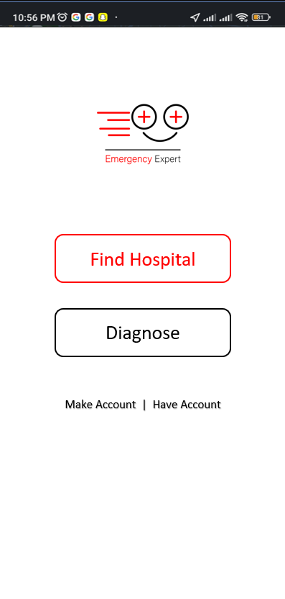 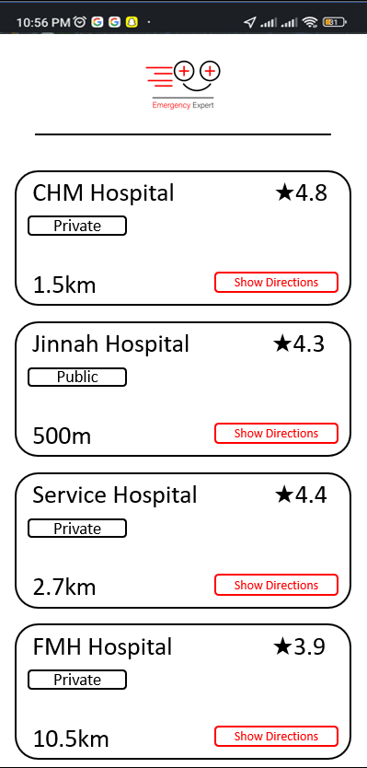 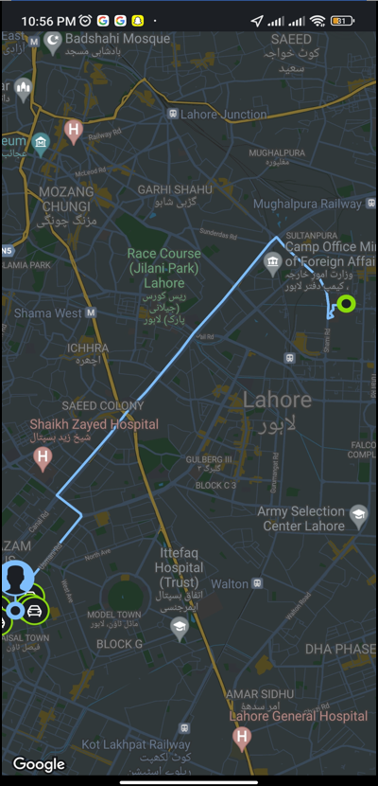

Fig1.1: Front Page Fig1.2: Hospital List Page Fig1.3: Map Page

The Front Page as seen in fig 1.1 will consist of four options:

1. Find Hospital

It will show the user all the hospital that are the closest to the user with a predefined distance.

1. Diagnose

It will redirect the user to the Diagnose Question Page

#### Make Account

It will redirect the user to the Sign-Up Page

#### Have Account

It will redirect the user to the Log in Page

The Hospital List Page as seen in fig 1.2 will show the user a list of all the hospitals that are currently registered at the platform, which are closest to the user’s currently location. It will also show whether the hospital is private or government, the overall rating of the hospital which will be calculated by the feedbacks that will be received by the users who have been treated at that hospital and the distance between the user’s current location and the location of the hospital. When the user clicks on the “show Directions” button, the user will be redirected to the map page, where the optimal path to reach the hospital will be shown to the user.

The Map Page as seen in fig 1.3 will show the user the optimal path to reach the hospital will the user has selected.

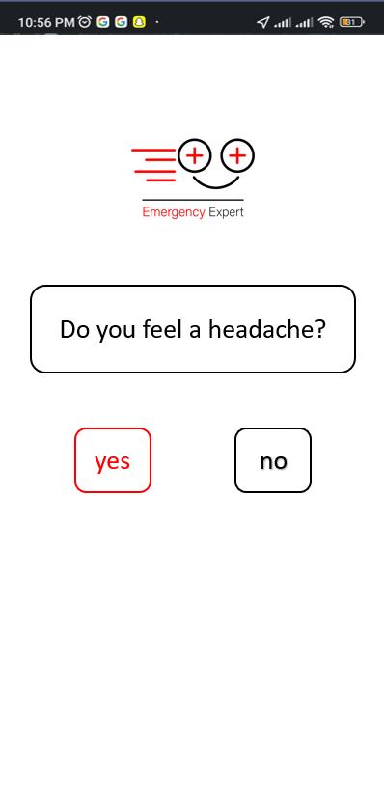 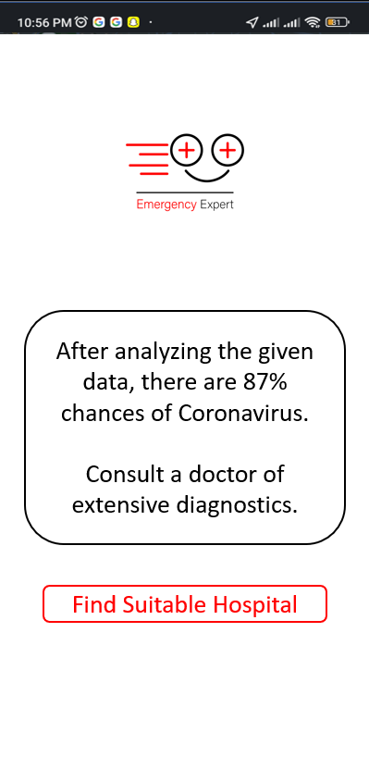

Fig1.4: Diagnose Page Fig1.5: Result Page

The Diagnose page as seen in fig 1.4 will ask the user easy-to-understand questions with only yes/no answers so that the system can diagnose the illness experienced by the user.

After the system has diagnosed the illness or after the system has reached the threshold of the maximum question to ask, the Result Page as seen in fig 1.5 will show the illness it has diagnosed that the user might be experiencing. When the user clicks on the “Find Suitable Hospital” button, the user will be redirected to the Hospital List page, where only the hospitals that are best suited to deal with the diagnosed illness will be listed.

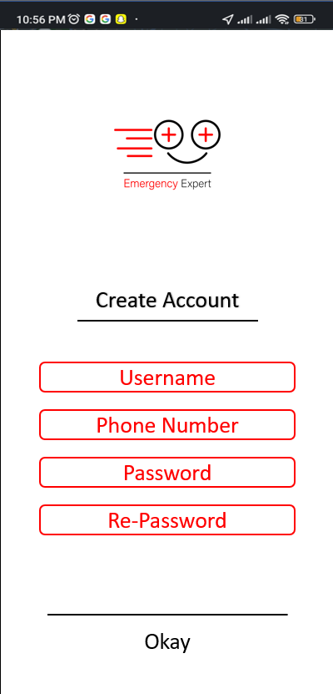 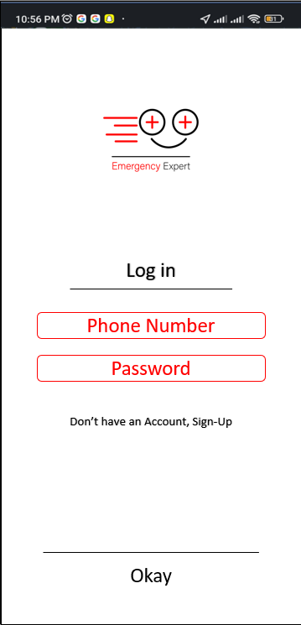

Fig1.6: Sign up Page Fig1.7: Log in Page

The Sign-up page as seen in fig 1.6 will help the user to make an account on the platform. The user will be required to provide the following information:

1. Username
2. Phone number
3. Password

After the requested information is provided by the user and (after verification) saved in the system, the user will be signed up and then redirected to the home page.

The Log-up page as seen in fig 1.7 will require the user to provide the following information:

1. Phone number
2. Password

After the requested information is verified by the system, the user will be signed up and then redirected to the home page.

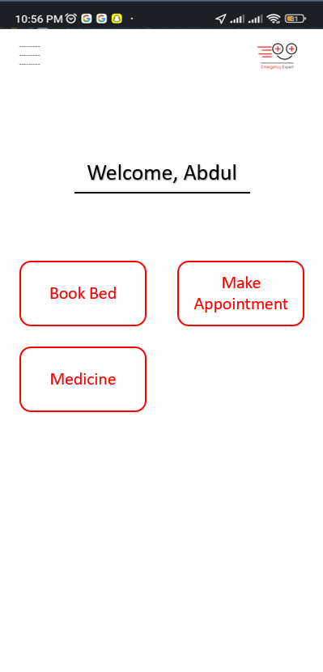 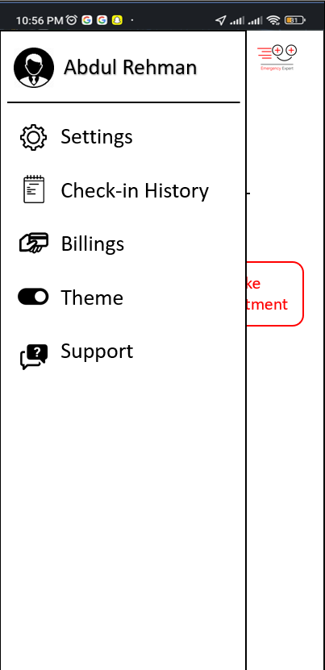

Fig1.8: Home Page Fig1.9: User Panel Page

The Home page as seen in fig 1.8 will help the user to either book bed, or make appointment or order Medicine. It will also help the user to access the control/user panel.

The User Panel page as seen in fig 1.8 will help the user to access:

1. Profile
2. Settings
3. Check-in History
4. Billings
5. Theme
6. Support.

## Database Design

### ER Diagram

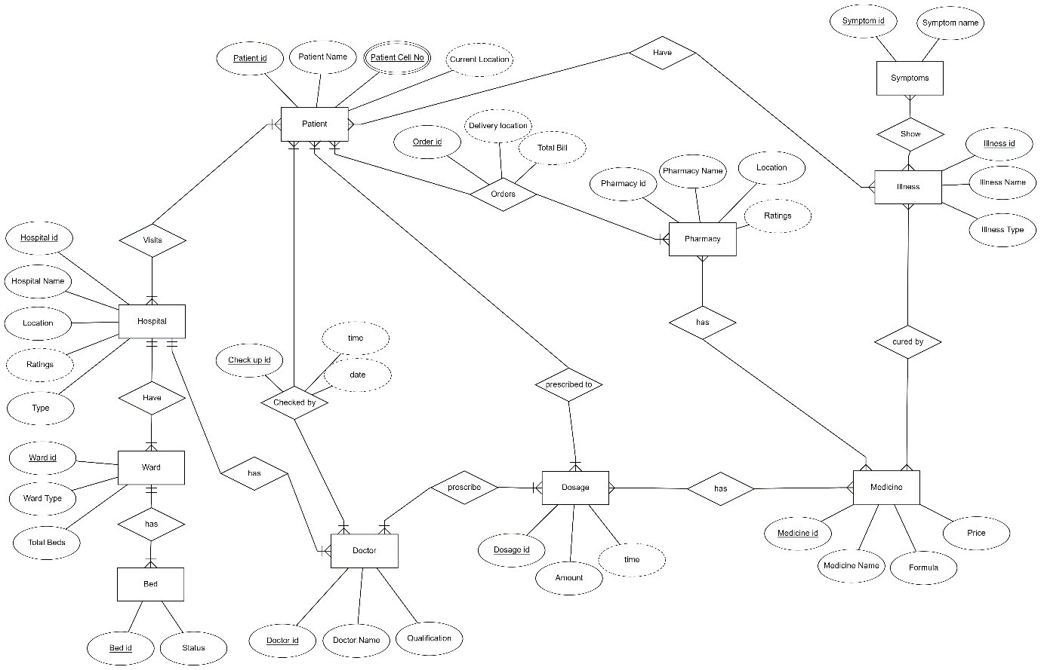

Fig1.10: Database ER Diagram

This is the Graphical ER Diagram of our database for this project.

### Data Dictionary

The Data Dictionary Table for the database is given below:

Table 2: Data Dictionary

|  |  |  |  |  |
| --- | --- | --- | --- | --- |
| Field Name | Data Type | Field Length | Constraint | Description |
| Patient id | int | 9 | Primary Key | id of the user and will be auto generated |
| Patient Name | varchar | 20 | Not Null | name of the user to show on profile |
| Patient Cell No | int | 11 | Primary Key | contact number of the user |
| Illness Id | int | 9 | Primary Key | id of illness and will be auto generated |
| Illness Name | varchar | 20 | Not Null | name of illness |
| Illness Type | varchar | 10 | Not Null | whether the illness is severe or normal |
| Symptom id | int | 9 | Primary Key | id of symptom and will be auto generated |
| Symptom Name | varchar | 20 | Not Null | name of the symptom |
| Hospital id | int | 9 | Primary Key | id of hospital and will be auto generated |
| Hospital Name | varchar | 20 | Not Null | name of hospital |
| Hospital Location | varchar | 50 | Not Null | location of the hospital |
| Hospital Type | varchar | 12 | Not Null | whether it is private or government |
| Hospital Ratings | float | 1 | Null | ratings of the hospital |
| Doctor id | int | 9 | Primary Key | id of the doctor and will be auto generated |
| Doctor Name | varchar | 20 | Not Null | name of the doctor |
| Qualification | varchar | 30 | Not Null | qualification of the doctor |
| Pharmacy id | int | 9 | Primary Key | id of pharmacy and will be auto generated |
| Pharmacy Name | varchar | 20 | Not Null | Name of pharmacy |
| Pharmacy Location | varchar | 50 | Not Null | Location of pharmacy |
| Pharmacy Ratings | float | 1 | Null | Ratings of pharmacy |
| Medicine id | int | 9 | Primary Key | id of medicine and will be auto generated |
| Medicine Name | varchar | 20 | Not Null | Name of medicine |
| Formula | varchar | 80 | Not Null | Formula of medicine |
| Price | int | 5 | Not Null | Price of medicine |
| Ward id | int | 2 | Primary Key | id of ward and will be auto generated |
| Ward Type | varchar | 15 | Not Null | whether it is ICU, General ward etc. |
| Total Beds | int | 20 | Not Null | total no of beds in the ward |
| Bed id | int | 2 | Primary Key | id of bed and will be auto generated |
| Status | varchar | 10 | Not Null | whether available or occupied |

## Risk Analysis

Risk Analysis that comes with the deployment of this project are as follows

### Financial

This project is an industrial level project which requires a large amount of computational power and resources along with real-time data of the medical institutes, to reach its full potential, therefore a considerable sum of credits will be invested in the project in order to avail the API and the Database and other deployment requirement.

### Legal

As the project also deals with online transactions and payments, so the services provide by the project must abide by the law of the state, otherwise, it can be charged with heavy fines by the government.

### Ethical

Since the project deals with Health Care, so all the Ethical rules and practices must be abiding by, as it must handle the life of people. Any loss in life caused by the use of this project or due to misfunction of its services may lead to violation of Ethical Laws and shut down of the whole project entirely.

# References

1. The Medical Futurist. (2019, Apr. 11). The Big Symptom Checker [Online]. Available: <https://medicalfuturist.com/the-big-symptom-checker-review/>
2. Team Software Suggest. (2019, Apr. 4). 10 Most Popular Hospital Bed Management Software [Online]. Available: <https://www.softwaresuggest.com/blog/best-hospital-bed-management-software/>
3. Altexsoft. (2020, Dec. 15). Symptom Checker APIs: How They Improve Medical Triage and Diagnosis [Online]. Available: <https://www.altexsoft.com/blog/symptom-checker-apis/>
4. Hospital bed management: An analysis from the perspective of the theory of constraints - Article in Espacios · January 2016 [Online]. Available: [(PDF) Hospital bed management: An analysis from the perspective of the theory of constraints (researchgate.net)](https://www.researchgate.net/publication/317001309_Hospital_bed_management_An_analysis_from_the_perspective_of_the_theory_of_constraints)
5. Hospital bed management: An analysis from the perspective of the theory of constraints - Article in Espacios · January 2016 [Online]. Available: <https://www.researchgate.net/publication/268037045_Inventory_Management_in_Pharmacy_Practice_A_Review_of_Literature>
6. A Review and Evaluations of Shortest Path Algorithms - Article in International Journal of Scientific & Technology Research · January 2013 [Online]. Available: [(PDF) A Review and Evaluations of Shortest Path Algorithms (researchgate.net)](https://www.researchgate.net/publication/310594546_A_Review_and_Evaluations_of_Shortest_Path_Algorithms)